Subjunctive - Stem-changing Verbs
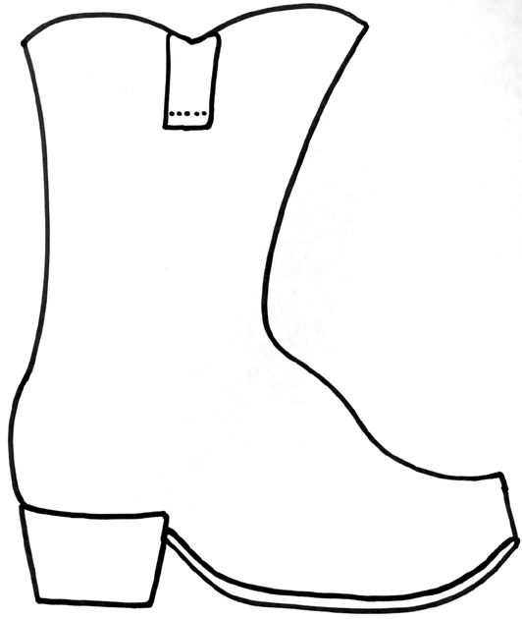
- –ar/-er stem changing verbs (BOOT)
*Change in all forms except for nosotros and vosotros.

Jugar (u>ue) - ________________

Entender (e>ie) - ______________

- –ir verbs (BOOT + SOCCER BALL)
*Change in ALL forms!
*In BOOT > has the normal stem-change for that verb (e>ie, e>i, o>ue)
*In SOCCER BALL > Only has a SINGLE letter change (e>i OR o>u)

Dormir (o>ue, o>u)

Divertirse (e>ie, e>i)

Pedir (e>i)

